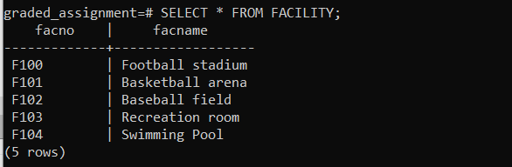

INSERT INTO facility (facno, facname)

VALUES ('F104', 'Swimming Pool');